

Antonino Frazzitta (s5117080)

10/11/2019

Interface Design Assignment 1

Personal Contribution

For the initial design of the game we brainstormed several ideas that could be implemented and follow the objective to simplify the load of information and the ease the human interaction. Here, where I came up with a partial diegetic UI and the contrast between outside world and the book (in 3D) and the inside GUI (in 2D).

After prototyping our personal screens, we combined the most functional parts.

For this project, we decided to split the level design into three, in my case I took the forest area. For the success of baking a good NavMesh I tackled the issue by tiling the level props and make them snap to each other.

I also took over the Hi-Fi design by giving shape of what we discussed together in the Lo-Fi stage by integrating a colour palette that could resonate with the mood of the game and at the same time be visually pleasing to interact with and also keep the original functionality of the Lo-Fi intact.

I spent some time to also help the character and prop Implementation and animation. In the process of this project I tried to evaluate and reiterate my work seeking everyone’s opinion.

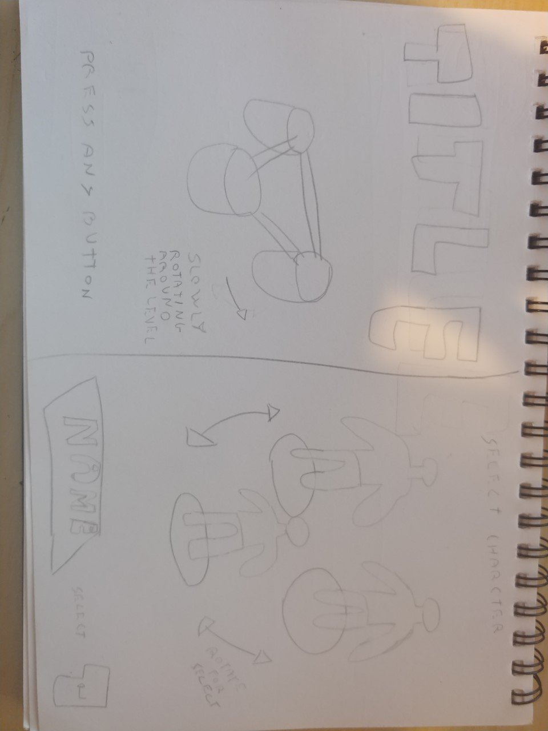

Fig 0.1 Left Title screen and Right Character selection (Personal Lo-Fi).

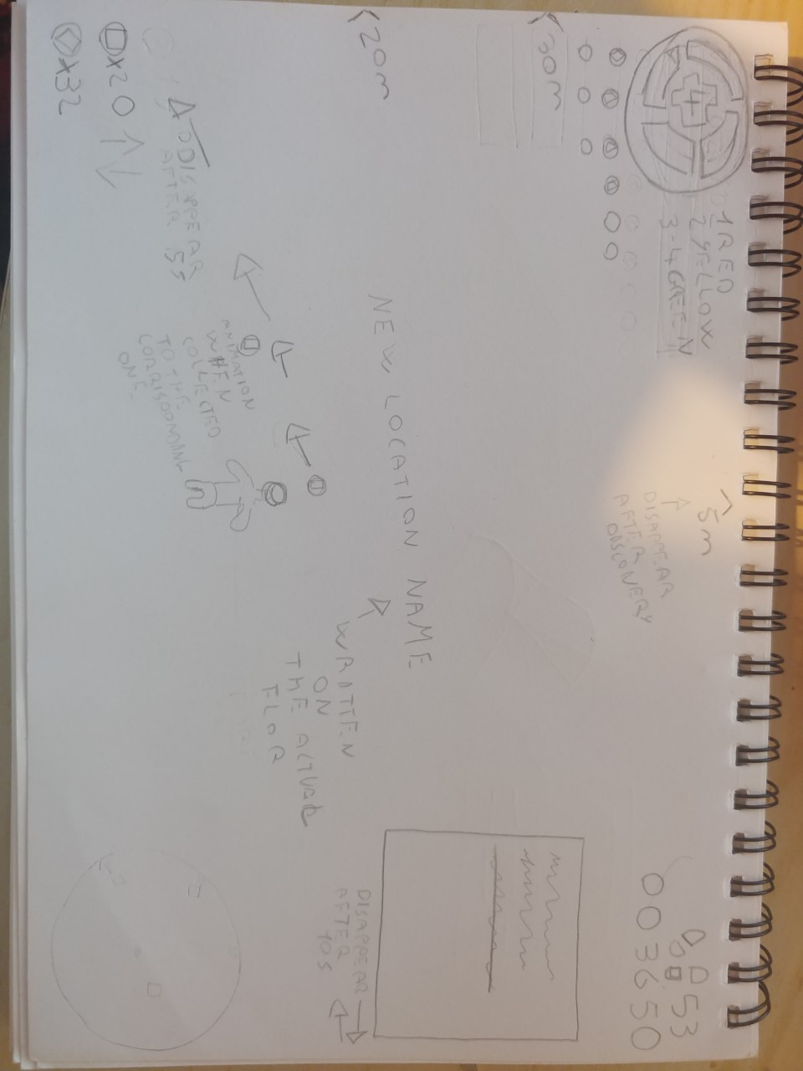

Fig 0.2 HUD (Personal Lo-Fi).

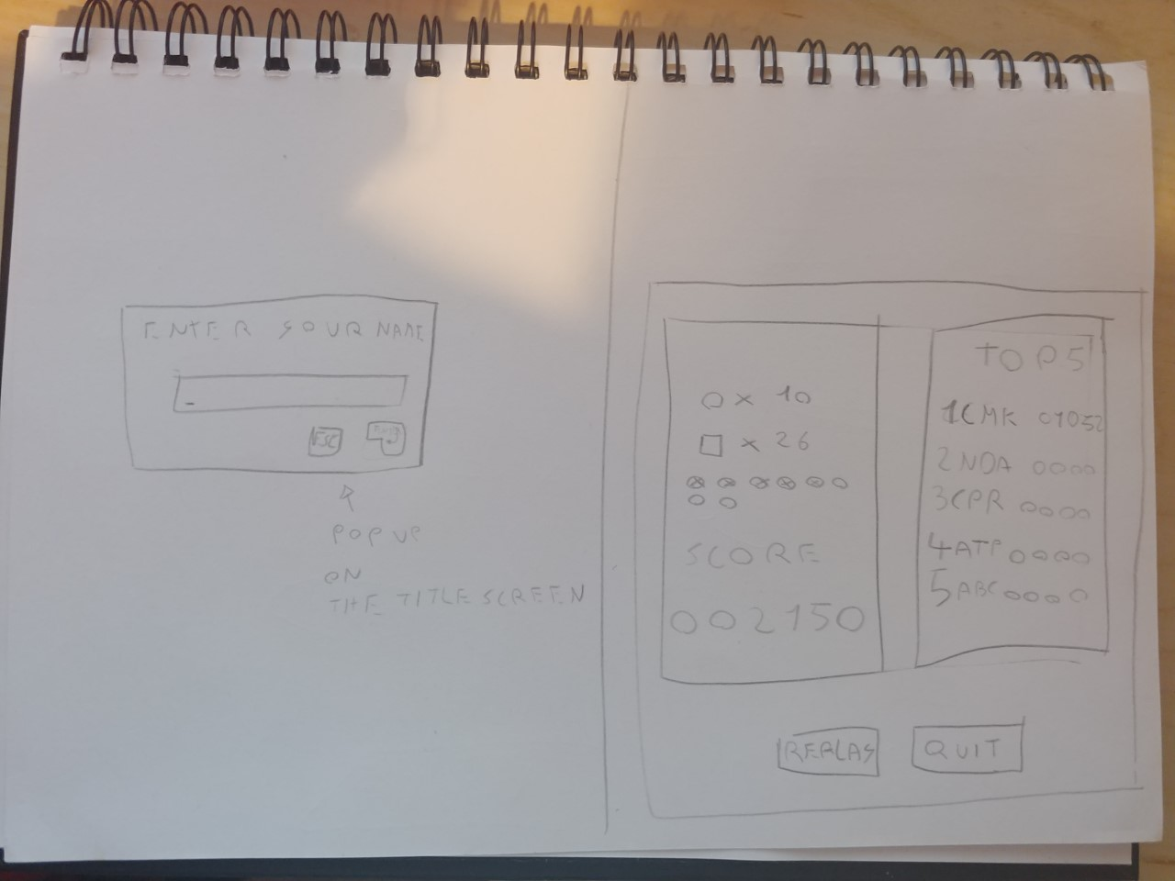

Fig 0.3 Left Pop-Up window for Player name (Personal Lo-Fi).

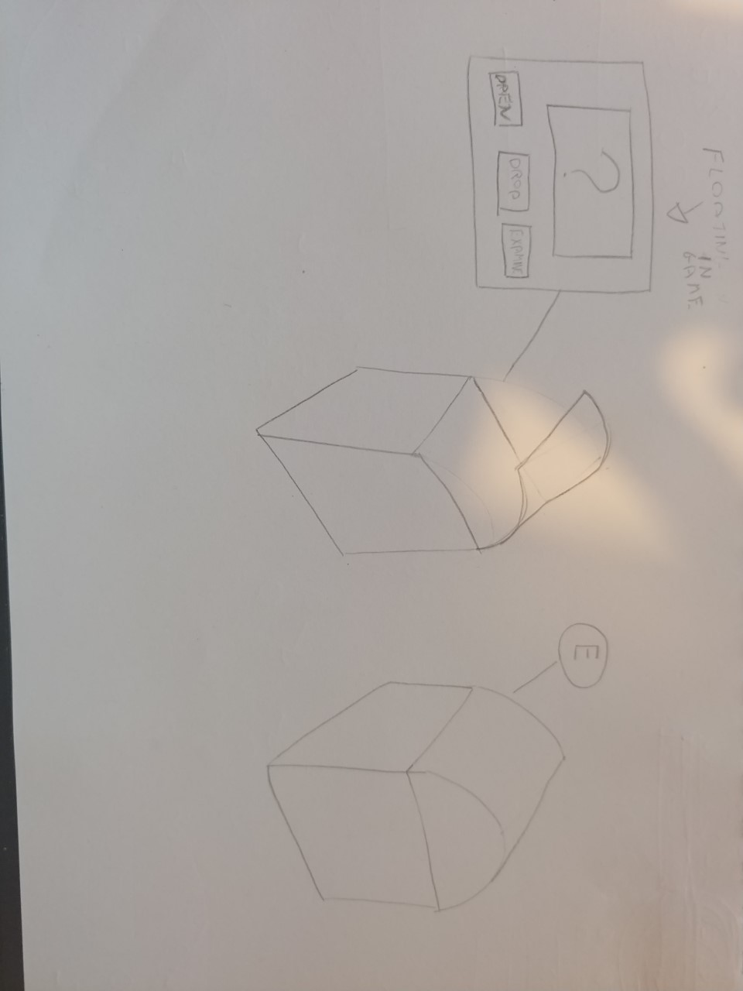

Fig 0.4 Chest with diegetic UI (Personal Lo-Fi).

Game idea and theme

Our game idea is a collection game with a fantasy medieval theme. We have used the idea of a book for the general aesthetics; UI, environment, and collectables are designed to fit into our fantasy tale. For example, the title screen is a cover of a book with a lock. These three locations are, a forest, a desert, and a dungeon. In addition, the three distinct areas act somewhat like chapters in a book offering differentiating environments to explore. We have three collectables and one unique collectable which are; coins, apples, key parts. The unique collectable being a chest where you have an option to open, leave, and examine the chest. There will be an animation somewhat akin to Mario Kart’s random collectables which cycle through possible options before outputting the item which can either increase or decrease score. We have implemented a hunger meter, step counter, score counter as well as coin counter and a visual indicator for the two parts of a key.

UI prototype

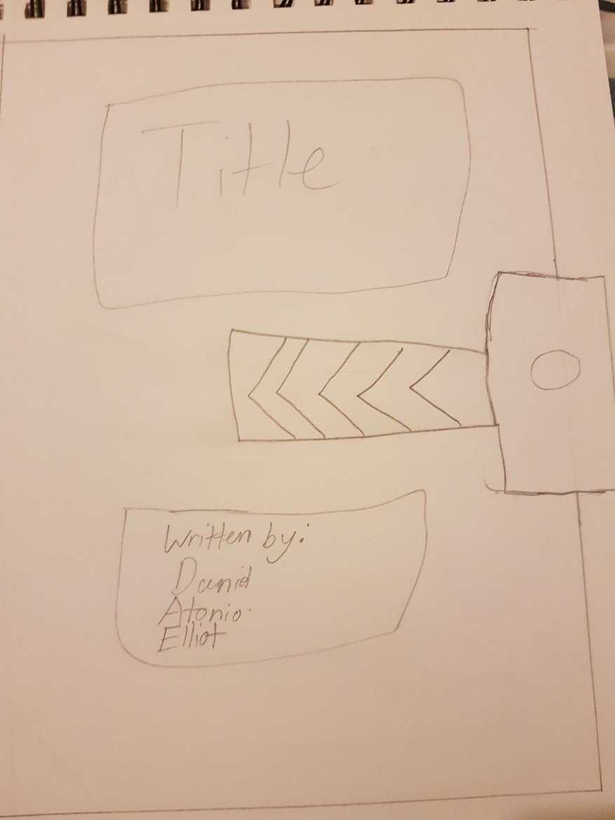We decided to all come up with lo-fi prototypes and after some discussion we came up with this lo-fi prototype:

This screen requires the user to click on the lock on the right-hand side of the book and dragging the mouse to the left mimicking the natural motion of opening a book.

fg1  
lo-fi title screen

An aesthetically pleasing design which targets minor usability issues. Easily understandable and eye-catching with the application of Fitts’ Law.

⠀⠀⠀⠀⠀⠀⠀⠀⠀⠀⠀⠀

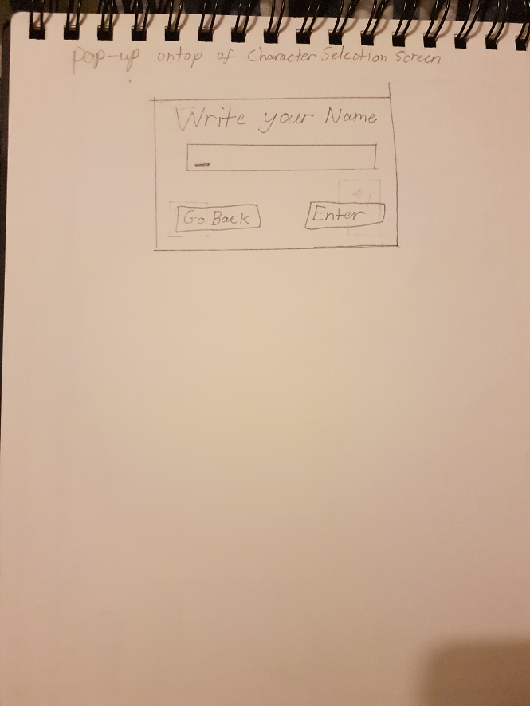This screen will pop up after the title screen asking for a user input.

Fg2   
lo-fi pop up menu

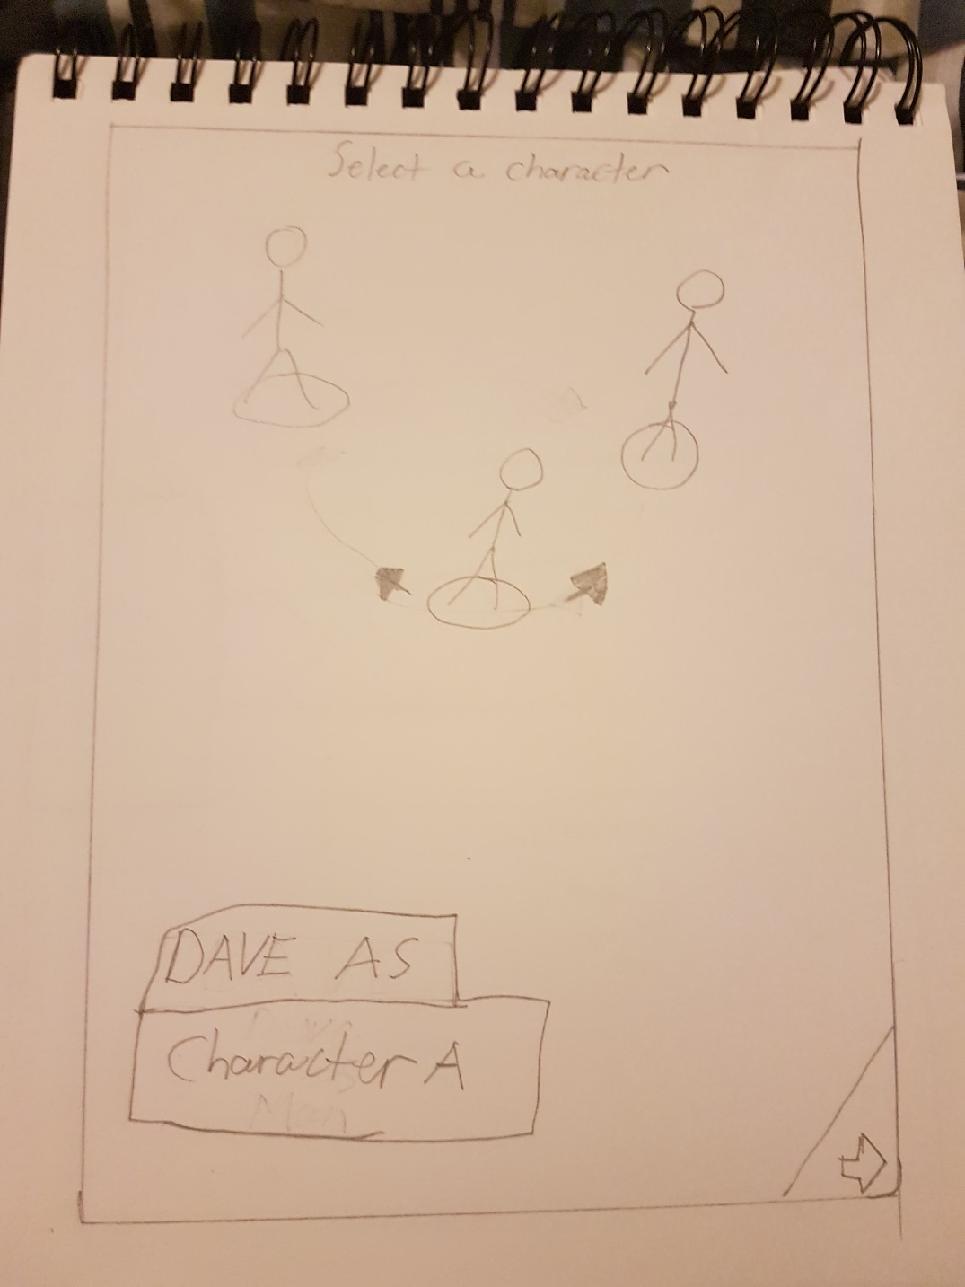

Fg3   
lo-fi character selection

We use a character wheel to spotlight the centre character drawing the user’s attention this makes the user understand which character is selected. The user will then see the bottom section of the screen showing the name they just entered as well as character name, this because our attention is drawn to main centre piece (that being the character), rather than the text box below. Once they have entered a character’s name, they can select the arrow in the bottom right corner this plays off the user’s preivous expreiance 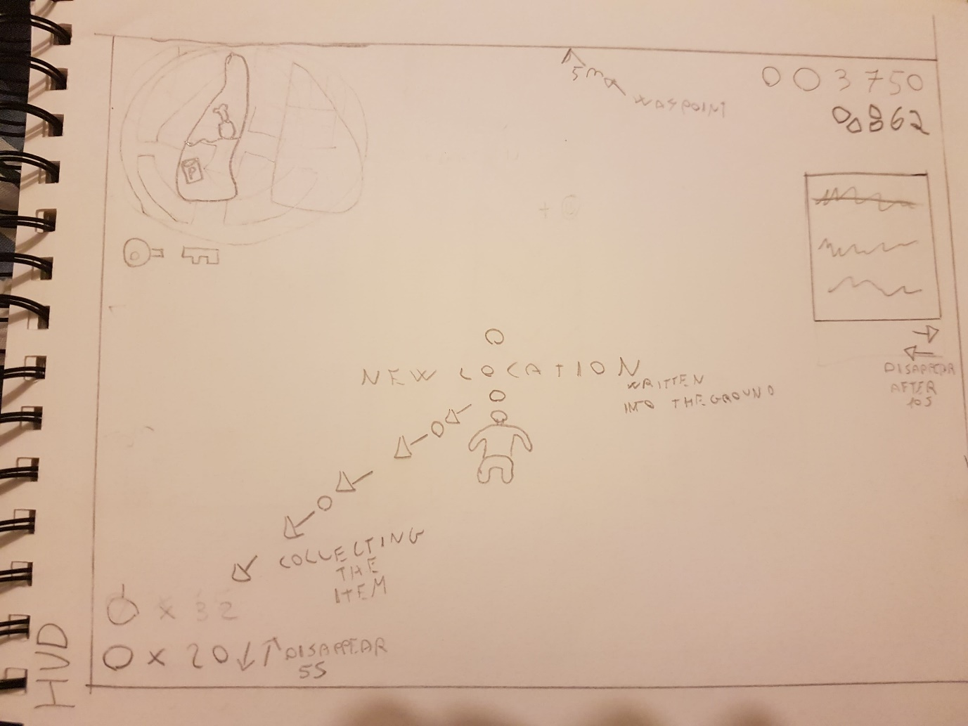with reading books and so the user will comprehend the motion used.

fg4  
lo-fi HUD

Most of our UI is explained using symbols rather than numbers, although there are numbers we have had to use e.g. score, step counter. Therefore we used symbols associtated with the number to indicate what they are; foot print silhouettes, coin symbol. The way we tell a user when they enter a new location will be displayed in a diegetic way with the names of locations being projected onto the ground. We have implemented a hunger system which is in the top left corner. The icon we used for this is a stomach that is full, the bar inside will deplete from the top, this is refilled by collecting apples. When this bar depletes fully it ends the game. Below the hunger bar there is two missing key fragments. These will fill as the user collects the respective parts. Finally, we have waypoints which are being used to guide the user to new locations.

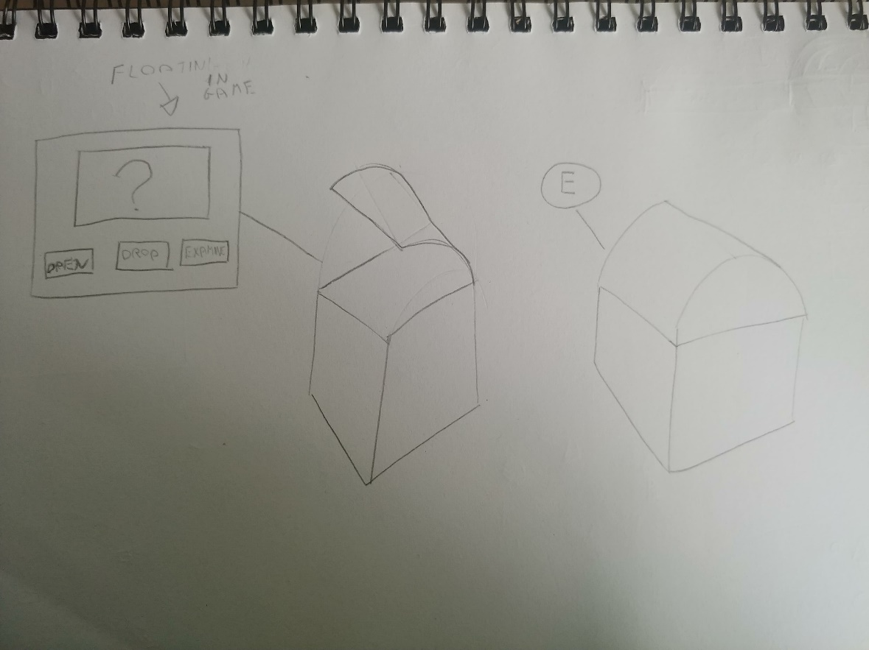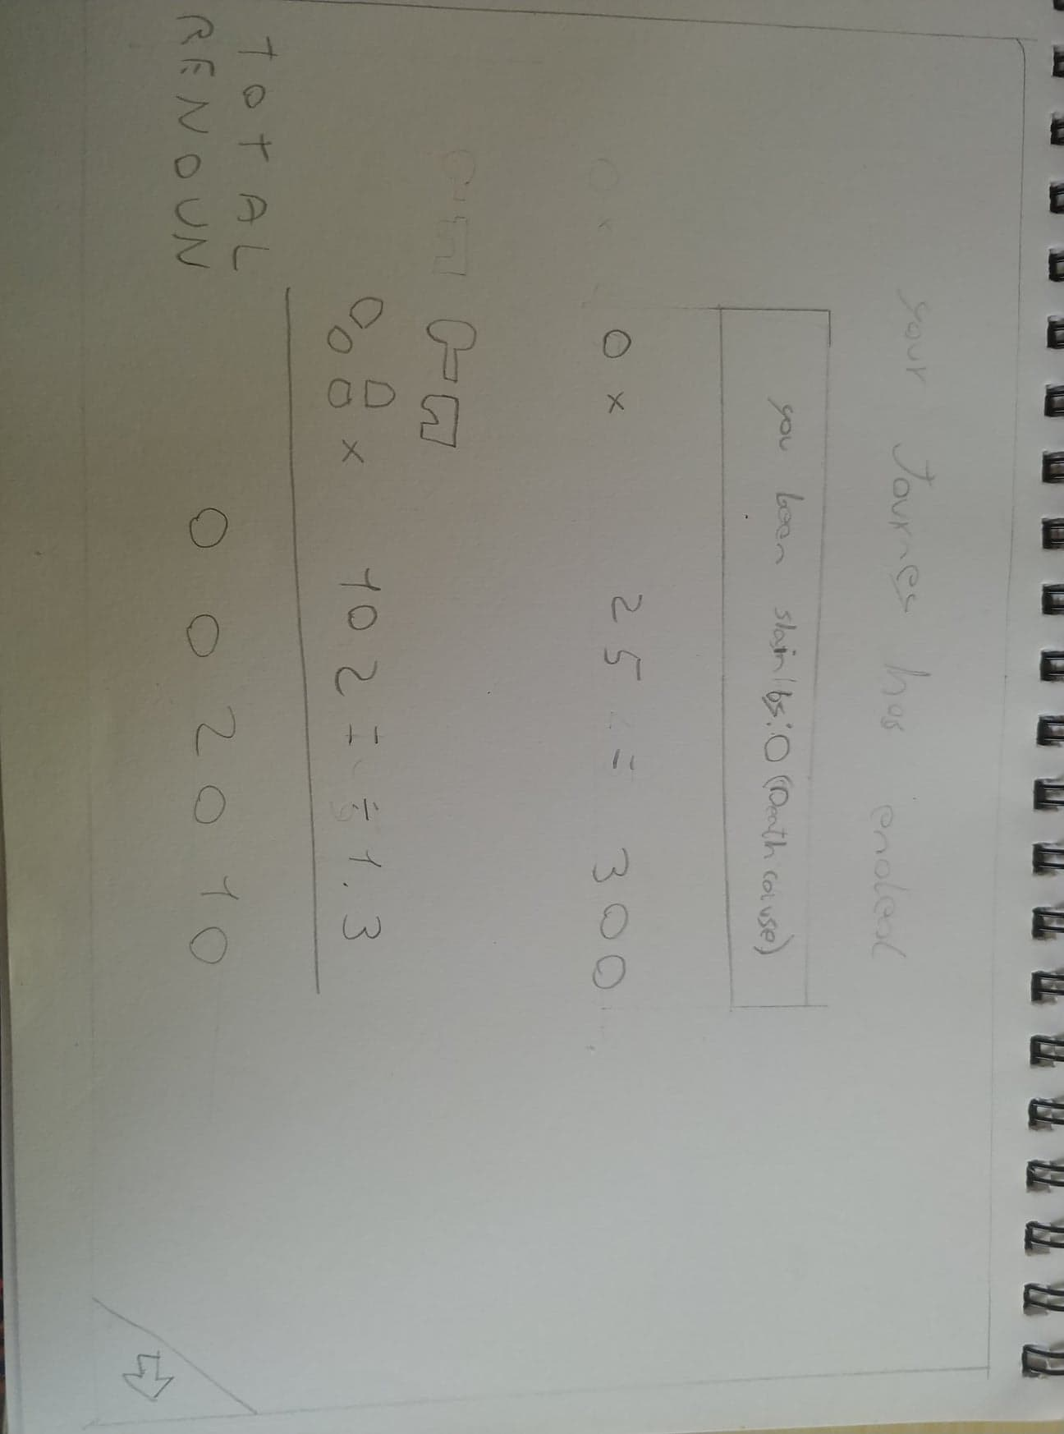fg5  
lo-fi  
chest pop up

This is our pop-up window for the chest as the user approaches it comes up with a button prompt and then when that button is pressed it will open with the pop-up on screen.

fg7  
 lo-fi score screen

Our score screen shows the outcome of the game. The arrow indicates for the player to continue to the next screen.

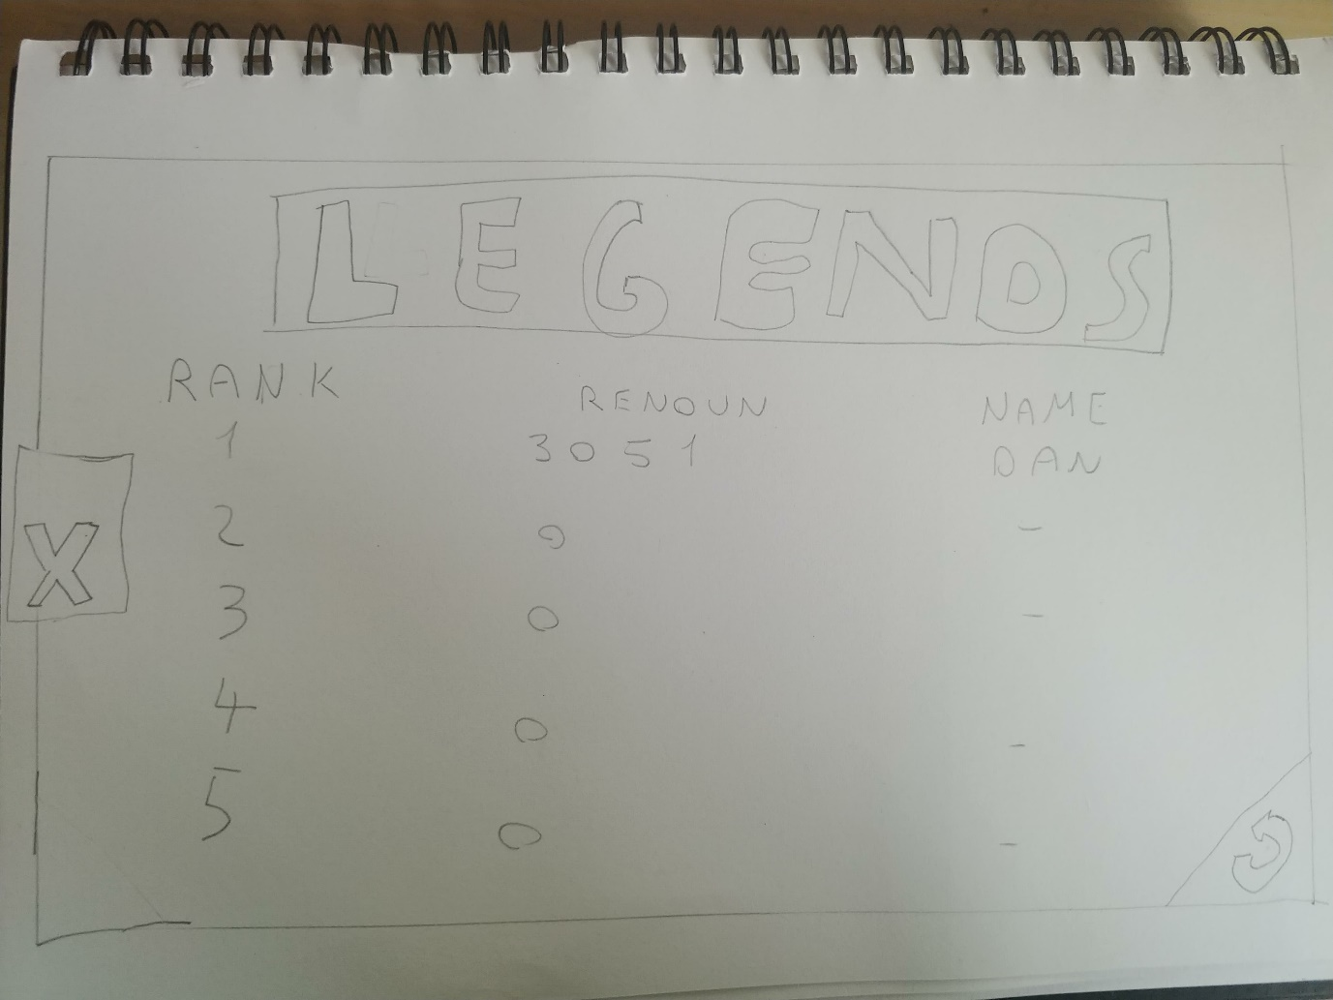fg8  
lo-fi high score screen

One button is used as a replay button which is the arrow in a circle pointing backwards. The second button is a cross that you click and drag, which is a call back to the beginning of the game where you open the book; the cross is used the close the book and go back to the title screen.

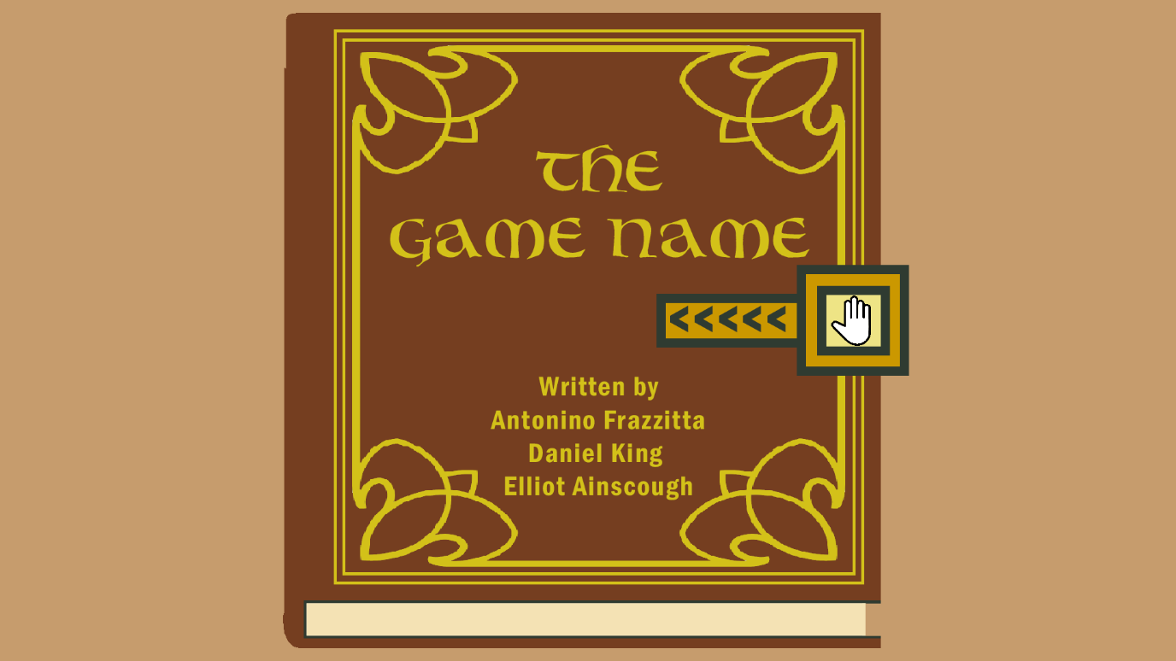Our hi-fi versions look like this

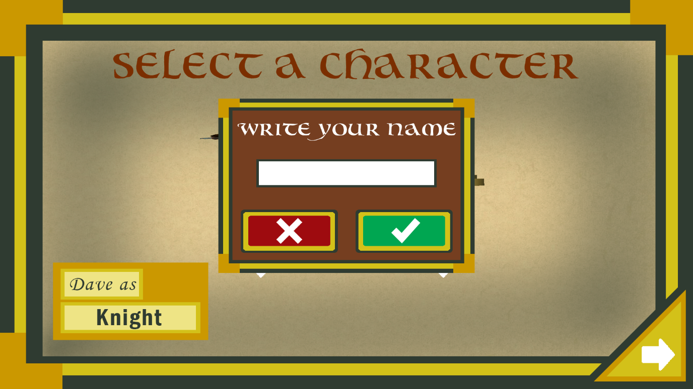We decided on a distinct colour pallet that suited our UI’s aesthetic

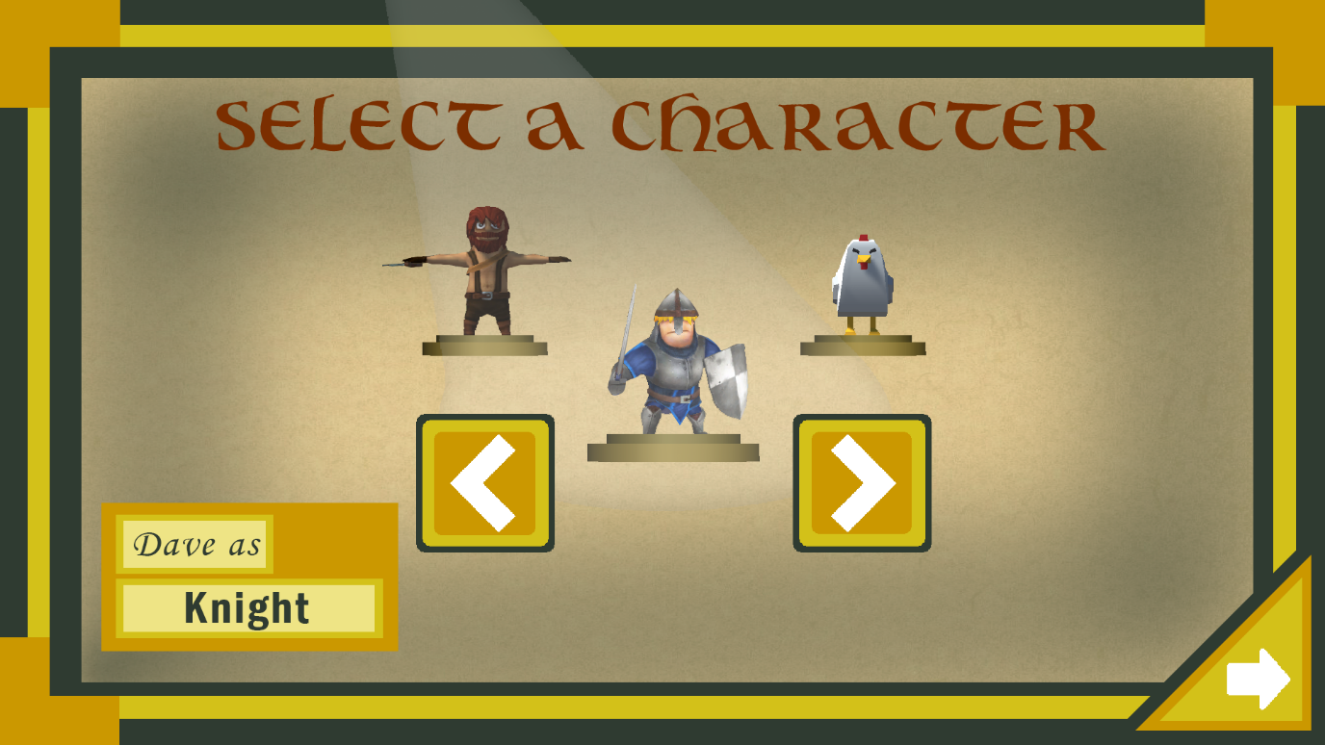

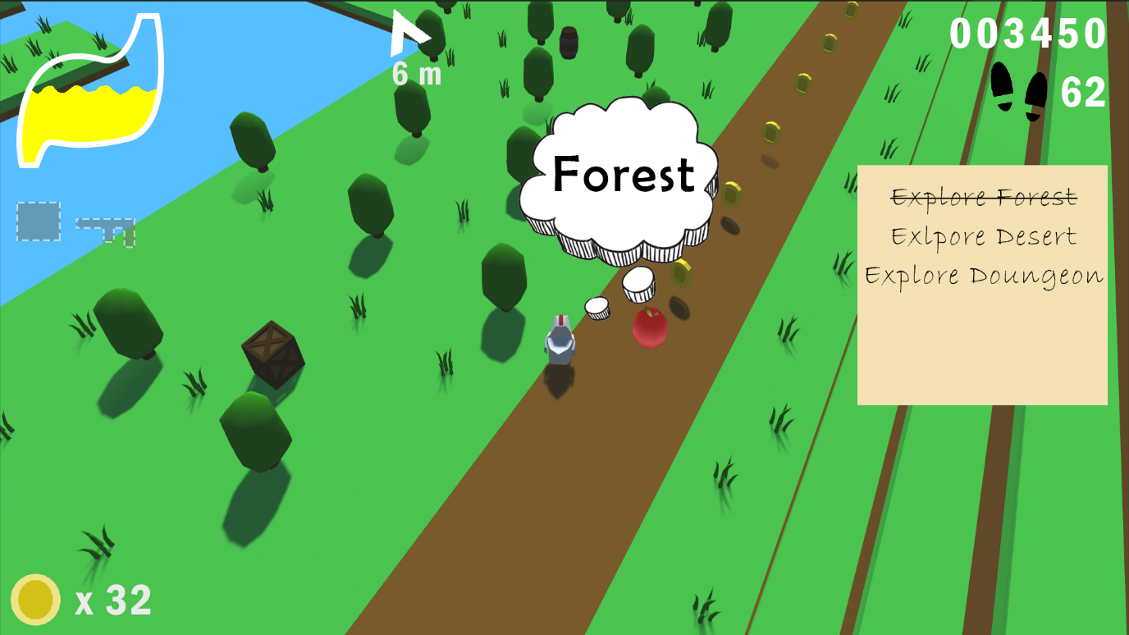

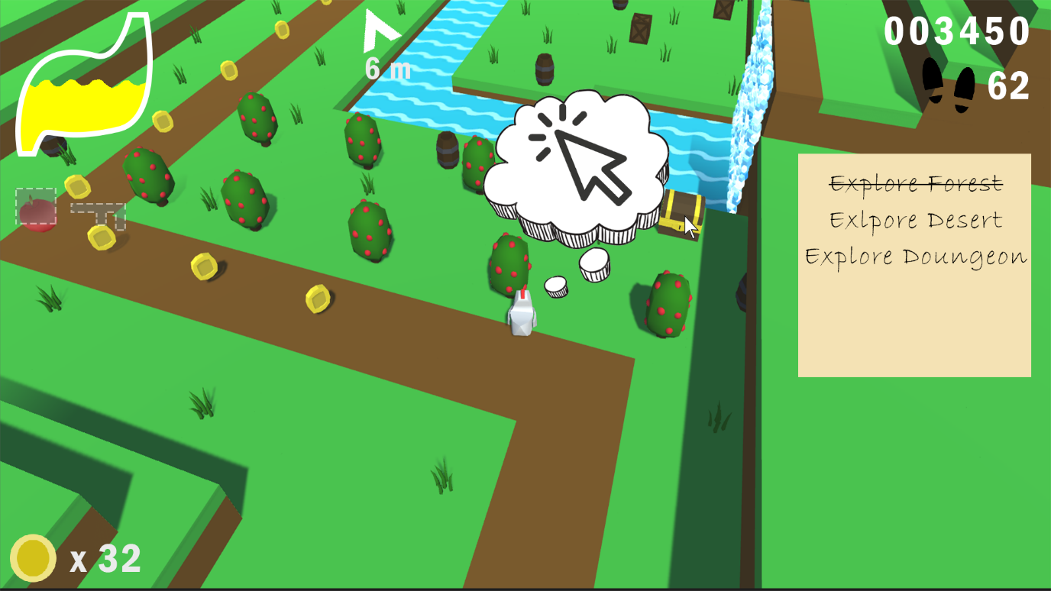

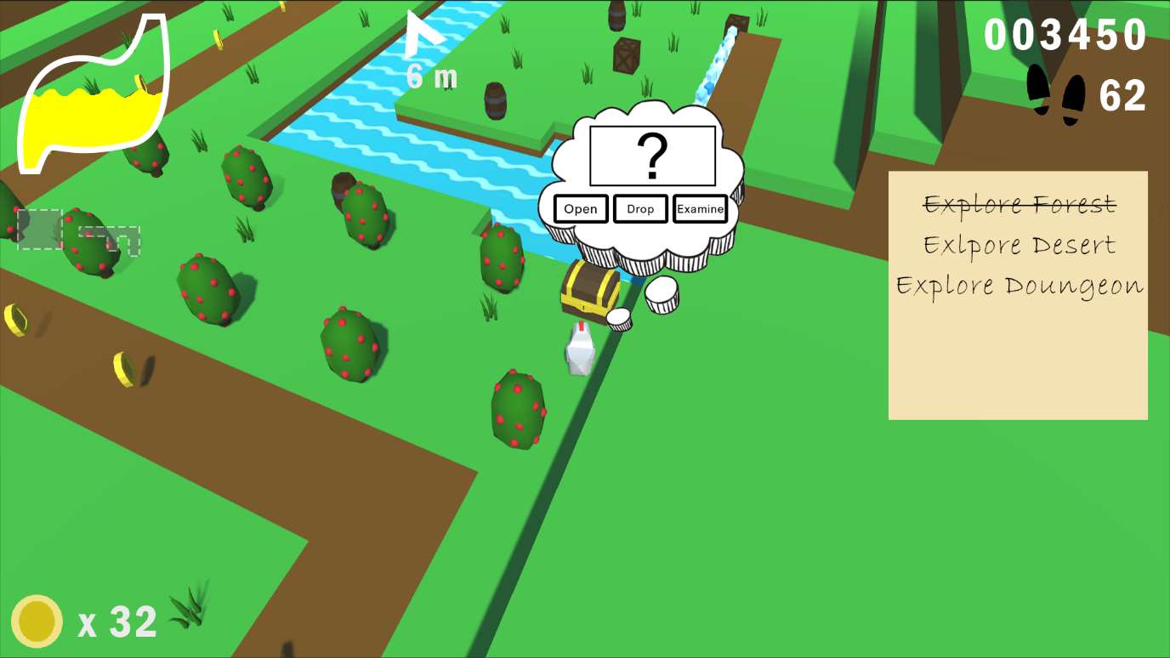

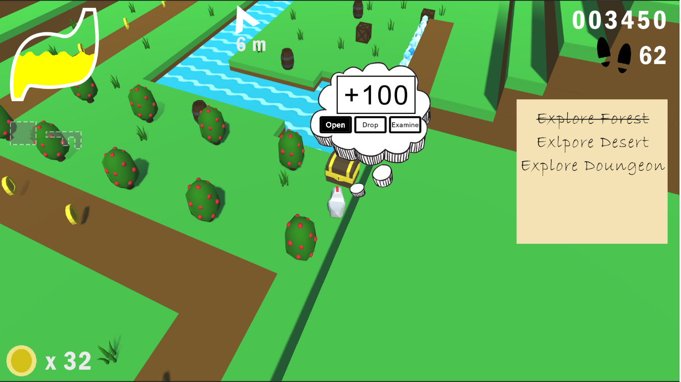

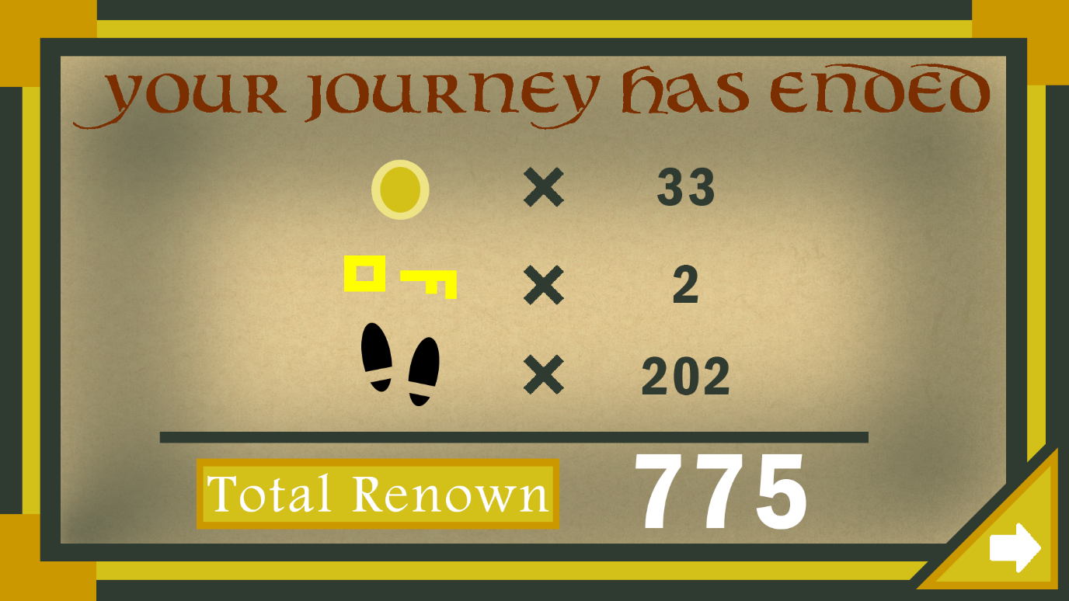

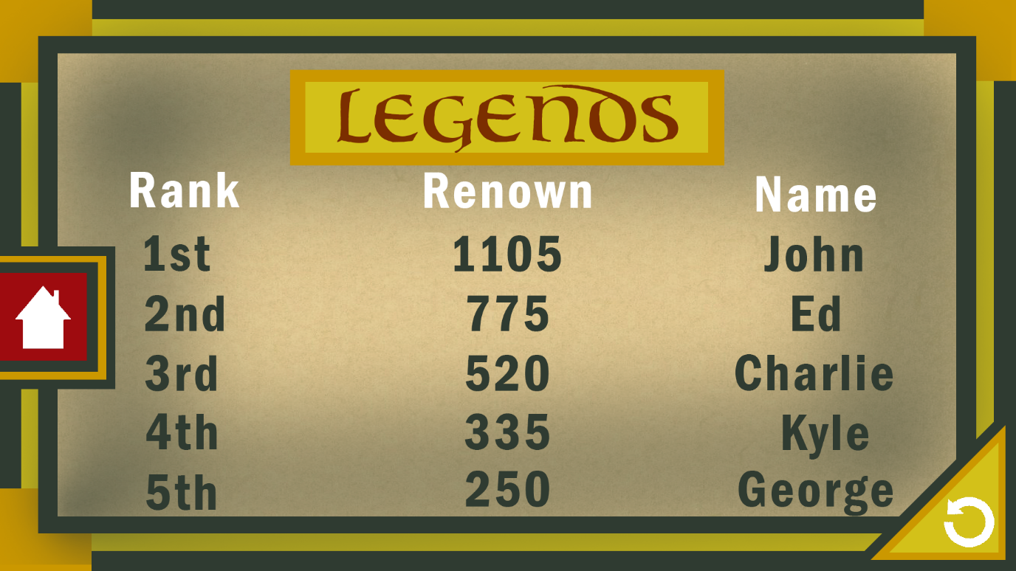

Conclusion and critical reflection

In conclusion our game utilises UI and UX theory such as the Aesthetic Usability Effect which is used in most of our UI especially for opening and closing the book, it is also using affordance in the title screen indicating to the user that the book is to be opened;, also by the use of the lock lighting up and glowing upon being moused over by the user. Another strength is the repeated use of the Law of Proximity in the high score screen with the three distinct rows indicating the scores belong to the user in the same row. A potential weakness of our UI is the step counter is not that clear with how it connects to the gameplay. It is only after the game has finished the user is told that your score is divided by the number of steps you take. To summarise, our game is a fantasy tale of a selected character and their adventure collecting coins, apples, keys and chests as they advance through different environments.

References

Norman, D., (2013) “*The design of everyday things*” New York: Basic Books.

Banerjee, J. C. (1994). "Gestalt Theory of Perception". *Encyclopaedic Dictionary of Psychological Terms*. M.D. Publications Pvt. Ltd.

Fitts, Paul M. (June 1954). "The information capacity of the human motor system in controlling the amplitude of movement". *Journal of Experimental Psychology*

Bouwsma “Uncial, font” Mouser Fonts <https://www.dafont.com/bouwsma-uncial.font?text=nce+upon+a+time>

Greek text box. Mr_Vector <https://gr.clipartlogo.com/istock/vertical-beautiful-book-cover-vector-border-frame-357350.html>

Traffic arrows vector image. Serhii435 <https://www.vectorstock.com/royalty-free-vector/traffic-arrows-vector-17823034>

Quote Bubble PNG Transparent HD Photo. Mar 20th, 2019. No Labelled Author <http://www.pngmart.com/image/138137>

Click Here Transparent #993087. Clipart Library <http://clipart-library.com/clip-art/61-617464_red-mouse-click-icon-png-download-click-arrow.htm>

Open Hand Icon. Prglot <https://www.pnglot.com/i/ioRbJTT_open-hand-comments-open-hand-icon/>

The Munchables. Namco Bandai JP: Namco. June 19, 2009.

Kissclipart white spotlight background. Kissclipart <https://www.kissclipart.com/white-spotlight-background-png-clipart-desktop-wal-qlzkit/download-clipart.html>

Dungeon Mason “Light Armour Footman HP” Unity Asset Store <https://assetstore.unity.com/packages/3d/characters/humanoids/light-armor-footman-hp-72070>

Meshtint Studio “Meshtint Free Chicken Mega Toon Series” Unity Asset Store <https://assetstore.unity.com/packages/3d/characters/animals/meshtint-free-chicken-mega-toon-series-151842>

HONETi “3 Free Characters: Lumberjacks” Unity Asset Store <https://assetstore.unity.com/packages/3d/characters/humanoids/3-free-characters-18098>

Rem Storms “Low Poly Fruit Pickups” <https://assetstore.unity.com/packages/3d/props/food/low-poly-fruit-pickups-98135>

Auryn Sky “Desert – Low Poly Toon Battle Arena/Tower Defense Pack” Unity Asset Store <https://assetstore.unity.com/packages/3d/environments/desert-low-poly-toon-battle-arena-tower-defense-pack-124507>

Auryn Sky “Forest – Low Poly Toon Battle Arena / Tower Defense Pack” Unity Asset Store <https://assetstore.unity.com/packages/3d/environments/forest-low-poly-toon-battle-arena-tower-defense-pack-100080>

Auryn Sky “Dungeon – Low Poly Toon Battle Arena / Tower Defense Pack” Unity Asset Store <https://assetstore.unity.com/packages/3d/environments/dungeons/dungeon-low-poly-toon-battle-arena-tower-defense-pack-109791>

Synty Studios “Simple Sky – Cartoon Assets” <https://assetstore.unity.com/packages/3d/simple-sky-cartoon-assets-42373>